## .Net Microservices

### Microservices Architecture

Large application is decomposed into set of smaller services.

* Microservices are small, independent, and loosely coupled. Each service is designed to perform a specific function and operates independently of others, promoting flexibility and scalability
* Each microservice has a separate codebase, managed by a small development team. This allows for agility in development, testing, and maintenance, as teams can focus on specific parts of the application without impacting the whole.
* Microservices are deployed independently. Teams can update or deploy individual services without needing to redeploy the entire application, enabling continuous integration and deployment practices.
* Microservices handle their own data management. Unlike monolithic architectures where a single database is often shared, microservices typically manage their own databases, which helps in ensuring data consistency and isolating failures.
* Communication between microservices is managed through well-defined APIs. Each service interacts with others through APIs, hiding the internal details of each service to promote decoupling.
* Supports polyglot programming. Microservices can be developed using different programming languages, databases, and tools, depending on what best fits their needs. This allows developers to use the right tool for the right task.

### Docker

Docker is an open-source project for ***automating the deployment of applications as portable, self-sufficient containers that can run on the cloud or on-premises***. Docker is also a company that promotes and evolves this technology, working in collaboration with cloud, Linux, and Windows vendors, including Microsoft.

#### Docker vs Virtual Machine

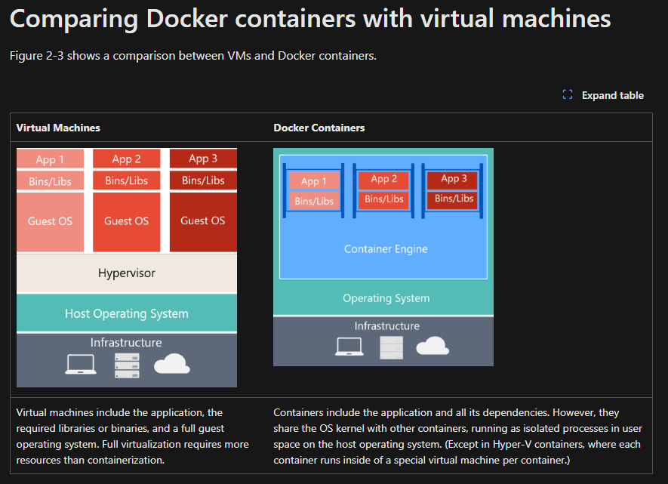

### Reference

1. Code: <https://github.com/dotnet/eShop/tree/main>
2. PDF: <https://dotnet.microsoft.com/en-us/download/e-book/microservices-architecture/pdf>
3. MSDN Ref: <https://dotnet.microsoft.com/en-us/learn/aspnet/microservices-architecture>

## Azure

### Roadmap

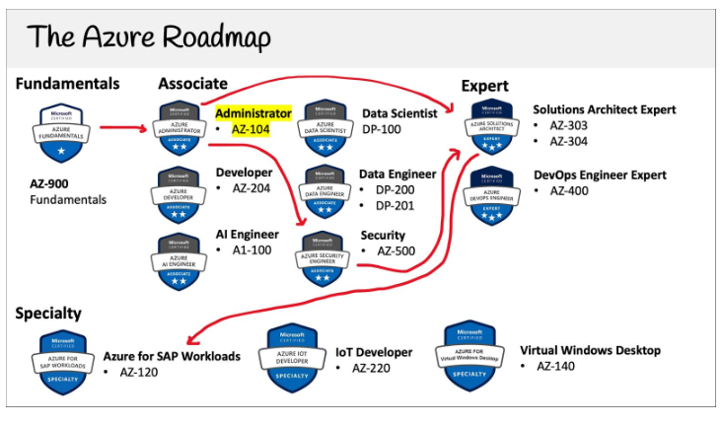

### Services

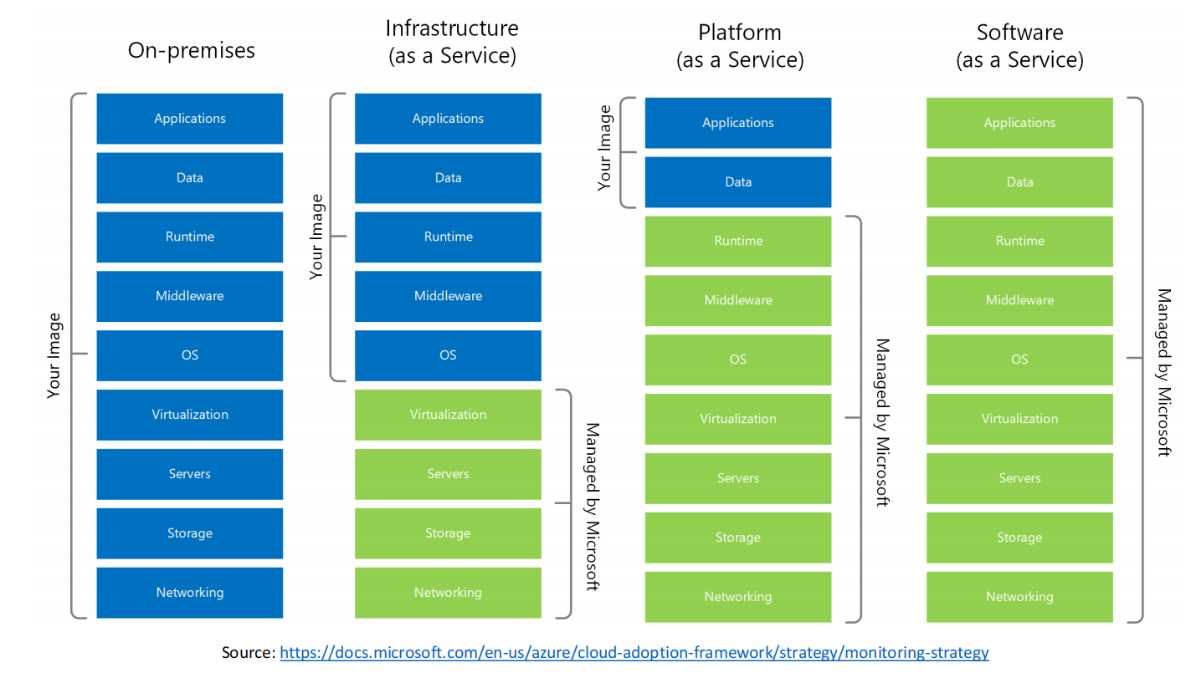

Additional services

